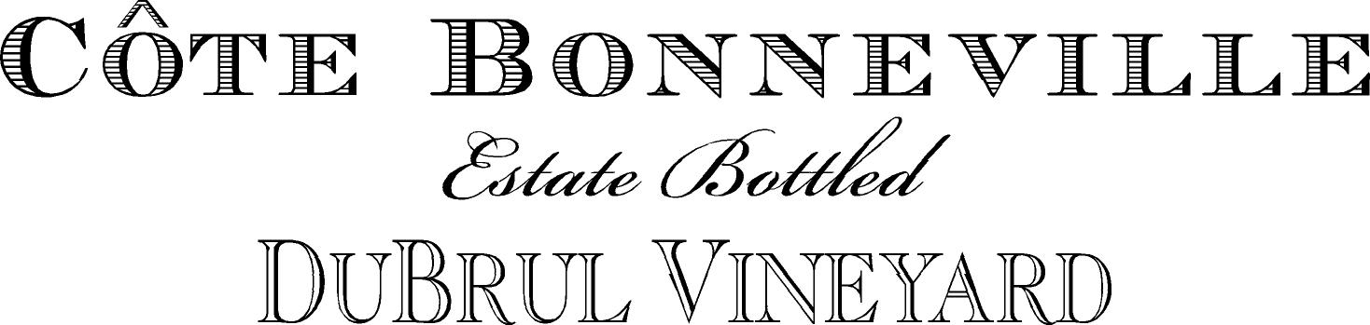

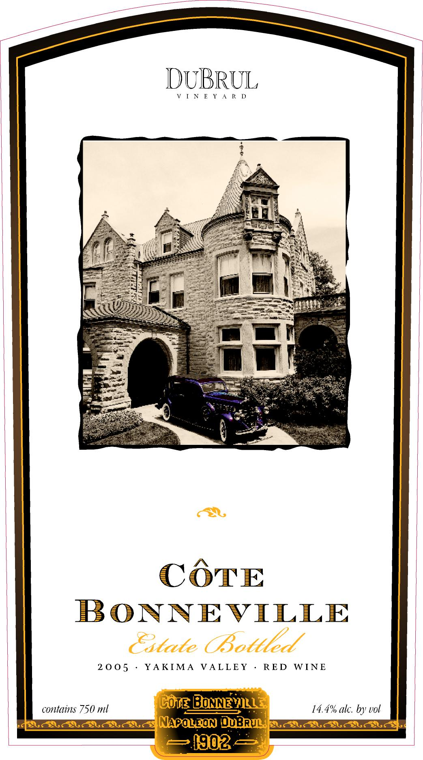
2006 Côte Bonneville DuBrul Vineyard

In 1992 we planted DuBrul Vineyard in the Yakima Valley, Washington’s oldest appellation. Our experienced team and spectacular site consistently produce grapes with unique flavors and structure. Meticulously cared for, DuBrul Vineyard was named “Vineyard of the Year” by SEATTLE Magazine in 2007 and again in 2009.

Côte Bonneville was founded in 2001 to create wines that best express our spectacular site each vintage year. By combining traditional winemaking techniques with cutting-edge science, we craft estate-grown grapes into world-class wines.

Tasting Notes

The 2006 Côte Bonneville DuBrul Vineyard represents the best expression of these 15-year-old vines. 2006 provided a growing season of normalcy, following the heat of ’03, the cooler ’04, and the drought of ’05. The hillside vines responded beautifully, providing a classic statement of our DuBrul Vineyard.

The wine is deep garnet in color, with a nose of exotic spice, deep cassis and cherry, with Kahlua undertones. Flavors of cherry, blackberry, raspberry, espresso and cocoa, backed by exotic spices including Indian long pepper are well integrated, palate coating, with the signature DuBrul length of finish.

Scores include 95 pts WS, 91 pts WA, 94 pts WE

Soils

On a steep rocky south facing hillside overlooking the Yakima Valley, our Cabernet Sauvignon vines grow in shallow Scoon soils. These were formed in wind-driven loess and heterogeneous rock deposited by the ancient Columbia River, which covers the underlying basalt promontory. Available water capacity is low, producing small clusters and small berries of intense fruit. The planting is at 1300 feet elevation, on an 8-15% pitch.

Just downslope from the Cabernet Sauvignon vines, at a gentler (5-8%) gradient, grow the Merlot vines. The soils are similar, shallow Scoon silt loam, underlain by basalt, with low available water capacity. These low yielding vines produce muscular Merlot.

Technical Data

Small lot fermentations in one ton fermentors, punched down by hand
French Oak Aging: 23 months in 100% new French oak cooperage.
Blend: 65% Cabernet Sauvignon, 35% Merlot
pH: 3.53
Titrable Acidity: 5.9 g/100 mL
Alcohol: 14.5%
Cases Produced: 500

