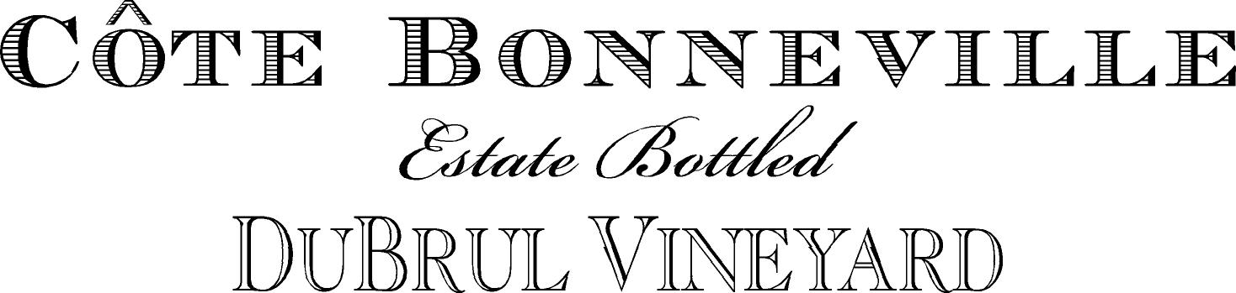

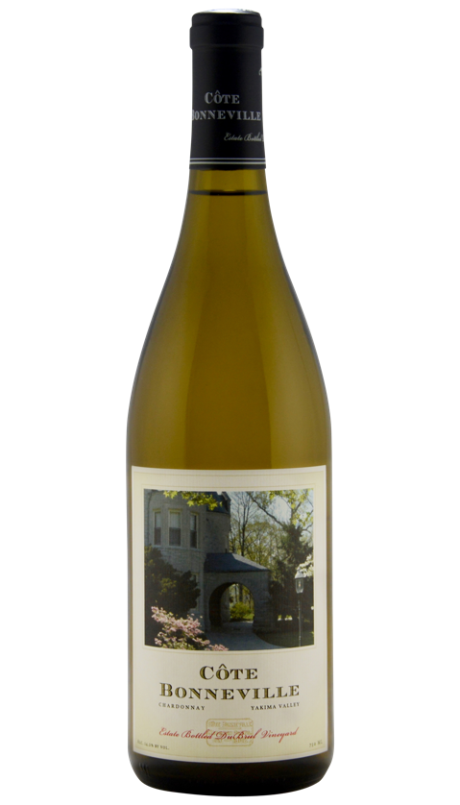
2019 Côte Bonneville Chardonnay

In 1992 we planted DuBrul Vineyard in the Yakima Valley, Washington’s oldest appellation. Our experienced team and spectacular site consistently produce grapes with unique flavors and structure. Meticulously cared for, DuBrul Vineyard was named “Vineyard of the Year” by SEATTLE Magazine in 2007 and again in 2009.

Côte Bonneville was founded in 2001 to create wines that best express our spectacular site each vintage year. By combining traditional winemaking techniques with cutting-edge science, we craft estate-grown grapes into world-class wines.

Tasting Notes

This is a stellar example of everything we love about DuBrul Chardonnay - that elusive balance of richness and texture with fruit and freshness. The combination of floral notes, lemon, and pineapple with creamy vanilla hazelnut make for a complex, alluring experience. This bottling gracefully brings together intense aromatics, bright acidity, and distinctive character. It’s a brilliant pairing with a range of foods - one of our favorites is marinated black cod.

Soils

Chardonnay grapes are sourced from two different vineyard sites, bringing complexity to the wine. The lower block, on a gentle 5% gradient at 1150 feet elevation, is composed of shallow Scoon silt loam soil, formed in loess, underlain by basalt. The fruit has a Meyer lemon highlight.

The upper vines grow on a steep (15-30%) side hill facing northwest at 1280 feet elevation, with two soil types. The shallow Scoon silt loam soil predominates. But there is an area of Burke silt loam soil, moderately deep and well drained on a 12% slope. These grapes have a pineapple, tropical fruit note that is very distinctive.

Technical Data

Fermented in Barrel, 100% malolactic fermentation
French Oak Aging: 17 months in 35% new French oak cooperage.
pH: 3.63
Titrable Acidity: 5.1 g/L
Alcohol: 14.2%
Cases Produced: 275

