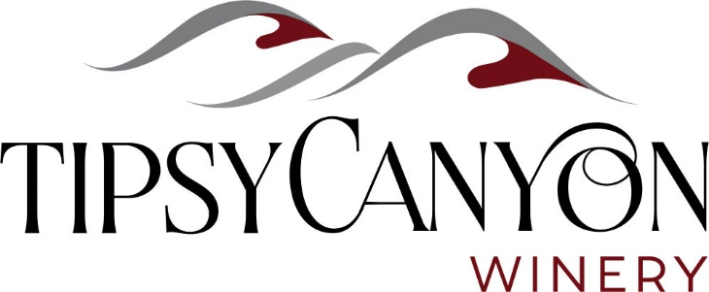
Wine Spec Sheet

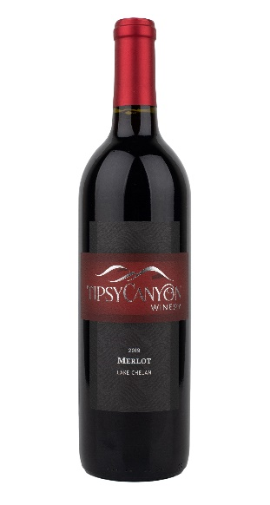
2019 Merlot
91% Merlot, 9% Cabernet Franc
Subtle hints of aged tobacco and ripe plums on the nose. Lovely black cherry and vanilla flavors enhanced by smooth moderate tannins.
Lake Chelan AVA, Amos Rome Vineyards
Fermented and aged in new and neutral French oak
ABV %14.5, PH 3.73, RS <0.1 g/l
114 Cases produced
TTB ID 19098001001103
Retail price $41.00
Double Gold – NCW Wine Awards
Top 20 Northwest Wines of 2021 – Pacific NW Magazine, Seattle Times

